**Lab Session**

The lab project aims to solve 2 problems. These problems will help you to apply logic in front-end development.

1. Create a Navigation menu bar with dropdown list
   1. Create header
   2. Create a nav bar with link 1, link 2, link 3.
      1. When hovering over link 2 and 3, show a drop down menu for each of them with DD_Link_1,DD_Link_2,DD_Link_3
      2. Apply all the required css properties like width, height, hovering properties, etc.,

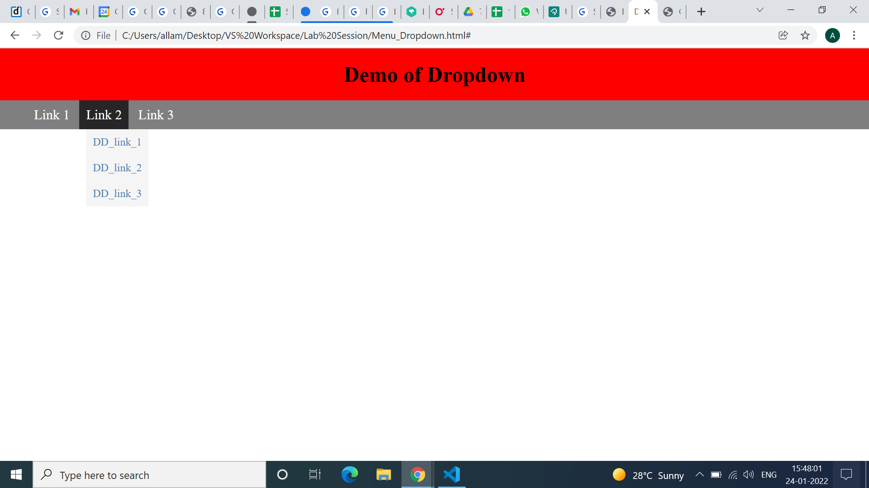

1. Create a gmail account creation form to take input from users as specified below. Take the below image as reference.
   1. Use background image/video for the page and fix it
   2. On focusing input tags change background color to steal blue with opacity 0.35
   3. Add submit and reset buttons
   4. Add border to the form

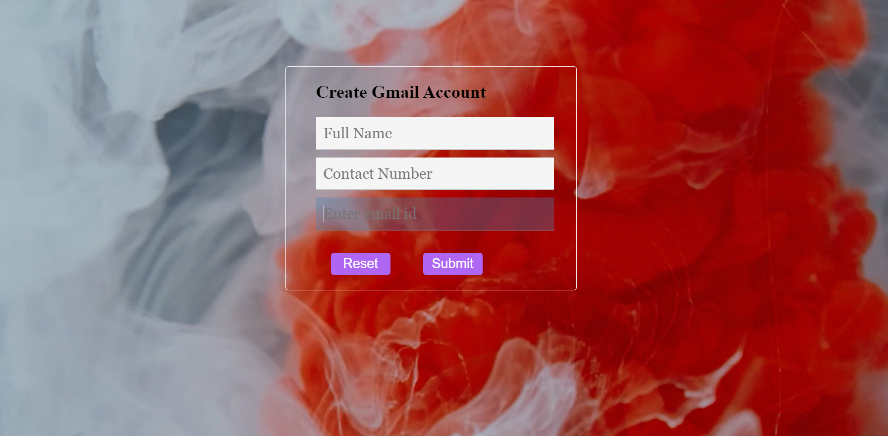

**Learning Objectives:**

1. Apply the concepts learnt to develop the web pages.
2. Be as creative as possible.
3. Have a good understanding of the concepts.